Algebra 2 Honors: Unit 7 Notes Name _____________________
Exponential & Logarithmic Functions
Day 1 – Exponential Growth and Decay
exponential function:

asymptote:
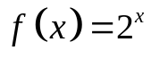
exponential growth function:

To graph exponential functions: 1.

2.
Example 1: Graph 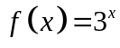 and give the following information.
asymptote:
D: R:
y-int:
increasing: decreasing:

end behavior: 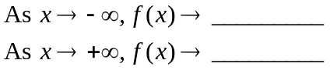

Example 2: Graph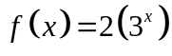 and give the following information.

parent function:

transformations from parent function:

asymptote:
D: R:
y-int:

Example 3: Graph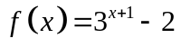 and give the following information.
parent function:
transformations from parent function:

asymptote:
D: R:
increasing: decreasing:
y-int:
Example 4: Graph 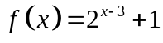 and give the following information.
parent function:

transformations from parent function:
asymptote:
D: R:
increasing: decreasing:
y-int:

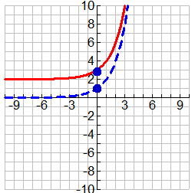
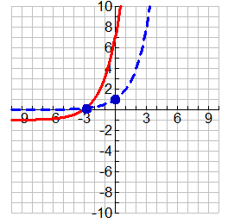
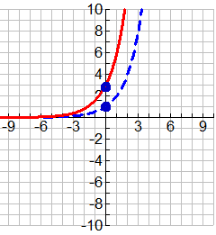
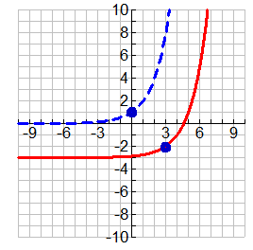
Example 5: Write the equation of each of the transformations of the graph of 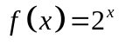. (The parent function is represented by the dashed line.)

a. ___________________ b. ___________________ c. _____________________ d. __________________

Exponential Decay
exponential decay function:

Example 6: State whether f(x) is an exponential growth or exponential decay function. Explain.
a) 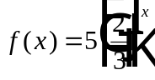 b) 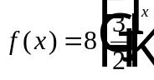 c) 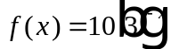
Example 7: Graph 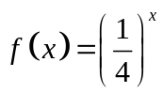 and give the following information.
parent function:
transformations from parent function:

asymptote:
D: R:
increasing: decreasing:
y-int: end behavior:
Example 8: Graph 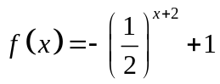 and give the following information.
parent function:
transformations from parent function:

asymptote:
D: R:
increasing: decreasing:
y-int:
end behavior:

Growth/Decay Models
For exponential growth, 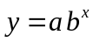 with 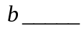, the value of 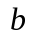 is the __________ factor. The percentage increase , written as a decimal, is the rate of __________ or growth __________. For exponential growth, 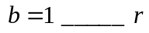.

For exponential decay, with 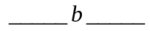, the value of is the __________ factor. The percentage decrease, written as a decimal, is the rate of __________. Usually a rate of decay is expressed as a ______________ quantity, so.

Exponential Growth/Decay Model:
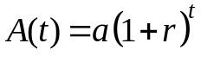

Example 9: You buy a savings bond for $25 that pays a yearly interest rate of 4.2%.
- Write an exponential model which indicates the value of the savings bond A(t) after t years.

- What will the savings bond be worth after fifteen years?

Example 10: You drink a Starbucks Grande coffee with 330 mg of caffeine. Each hour, the caffeine in your system decreases by about 12%. Write a model that gives the amount of caffeine A(t) (in mg) t hours after you begin drinking the beverage. Then, find how long after you begin drinking the beverage will you have 165 mg of caffeine in your system. How long before you have 90 mg of coffee in your system?

Example 11: Anna opens a savings account that pays 4.5% annual interest. If Anna’s initial investment is $300 and she makes no additional investments or withdrawals, how many years will it take before Anna’s account will grow to at least $500?

Example 12: The initial value of Fred’s used Cadillac is $30,000. After one year, the value of the Cadillac is $20,000. Estimate the value of the Fred’s car after 5 years.

Example 13: The table shows the world population of the Iberian lynx in 2003 and 2004. If this trend continues and the population is decreasing exponentially, how many Iberian lynx will there be in 2014? In 2020? If this trend has been occurring since the lynx was placed on the Endangered Species List in 1970, how many Iberian lynx were there when it was placed on the list? Is this reasonable? If the trend continues, in what year will there be no hope of a wild Iberian lynx recovery (excluding captive animals)?
World Population of Iberian Lynx
Year | 2003 | 2004
Population | 150 | 120

Day 2: The Number e
Up to this point you have worked with exponential functions with _____________________ bases (numbers that can be expressed as a ratio). However, exponential functions can have ______________________ bases as well. One important irrational base is the number e.
The history of mathematics is marked by the discovery of special numbers such as the counting numbers, zero, negative numbers, pi, and imaginary numbers. In this lesson you will study one of the most famous numbers of modern times. Like pi and i, the number e is denoted by a letter. The number is called the natural base e, or the Euler number, after its discoverer, Leonhard Euler (1707-1783).
Investigating the Natural Base e: How large will $1.00 grow when invested at 100% interest for 1 year?
Use a calculator to fill in the table.
n | 1  (annually) | 2  (semi-annually) | 4 (quarterly) | 12 (monthly) | 365  (daily) | _______  (hourly) | ____________  (every minute)
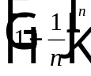

Do the values appear to be approaching a fixed decimal number? If so, what is the number rounded to three decimal places?
The Natural Base e:
As 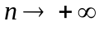, 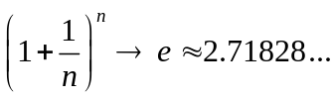

Example 1: Simplify the expression.
a) 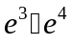 b) 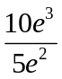 c) 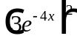 d) 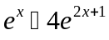

e) 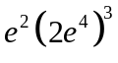 f) 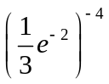 g) 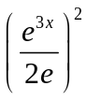 h) 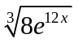

Example 2: Use a graphing calculator to evaluate the expression.
a) 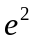 b) 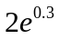 c) 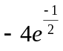 d) 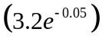

A function of the form 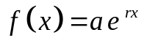 is called a natural base exponential function.
***If a > 0 and r > 0, the function is an exponential growth function.
***If a > 0 and r < 0, the function is an exponential decay function.

Example 3: Graph the function.
a) 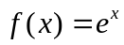 b) 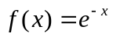

c) 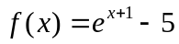 d) 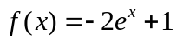

In lesson 7-1, you studied interest that was compounded annually. The formula for continuously compounded interest uses the number e.
Continuously Compounded Interest:
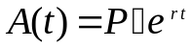
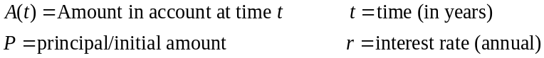

Example 4: Suppose you won a contest at the start of 5th grade that deposited $3000 in an account that pays 5% annual interest compounded continuously. How much will you have in the account when you enter high school 4 years later? When you enter college 8 years later? Express your answer to the nearest dollar.

Day 3 Common & Natural Logarithmic Functions
Example 1: Solve for x.
Logarithm Definition:
A logarithm base b of a positive number x satisfies the following definition:
For 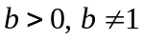 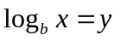if and only if 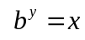
You read 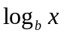 as “log base b of x”.
In other words, the logarithm y is the exponent to which b must be raised to get x.
a) 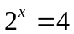
b)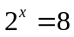
c) 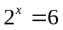
Exponential form: 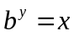

Logarithmic form:
Example 2: Write the equation in exponential form.
a) 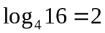 b) 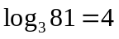 c) 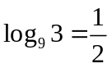 d) 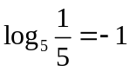

Example 3: Write the equation in logarithmic form.
a) 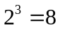 b) 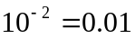 c) 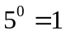 d) 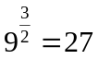

Special Logarithm and Natural Logarithm Values
Let a and x be positive numbers such that 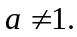
1. 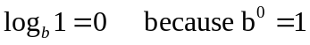 1. 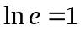
2. 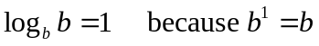 2. 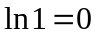
3. 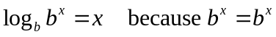
Your calculator has two keys for logarithms: LOG (base 10) and LN (base e).

Common Logarithm is base 10.

Denoted by 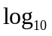 or simply by 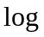.
Natural Logarithm is base e.
Denoted by 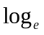 or 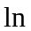.

Example 4: Simplify/evaluate the expression.
a) 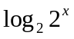 b) 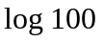 c) 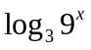 d) 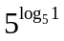

e) 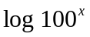 f) 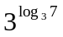 g) 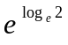 h) 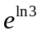

i) 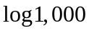 j) 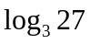 k) 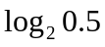 l) 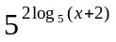

m) 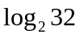 n) 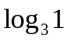 o) 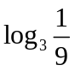 p) 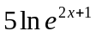

q) 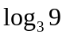 r) 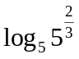 s) 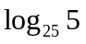 t) 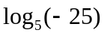

Example 5: Simplify/evaluate the expression. (Solve for x)
a) 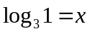 b) 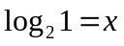 c) 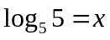 d) 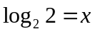 e) 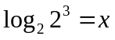

f) 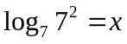 g) 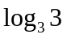 h) 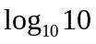 i) 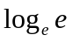 j) 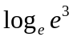

k) 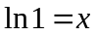 l) 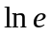 m) 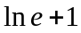 n) 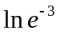 o) 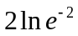

Example 6: Fill in the chart with the equivalent equation.
Logarithmic Form  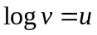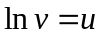 | Exponential Form  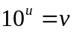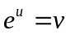
 | 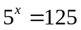
 | 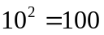
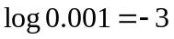
 | 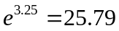
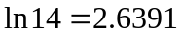
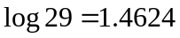

Graphs of Logarithmic Functions
 | Exponential Function | Logarithmic Function
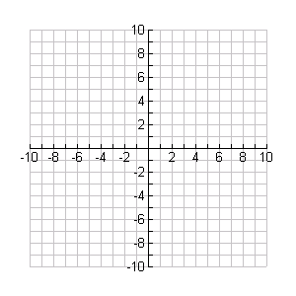 | 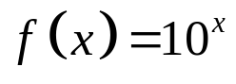 | 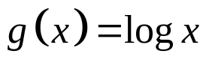
domain
range
asymptote
reference point
end behavior | 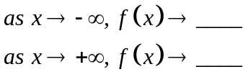 | 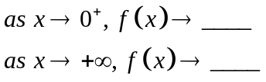

 | Exponential Function | Logarithmic Function
 | 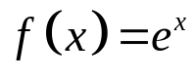 | 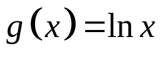
domain
range
asymptote
reference point
end behavior

The graph of 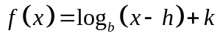 has the following characteristics:
- The line 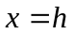is a vertical asymptote.
- The domain is 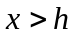, and the range is all real numbers.
- If 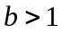, the graph moves up to the right (increases).
- If 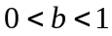, the graph moves down to the right (decreases).

**Steps to Graph a Logarithmic or Natural Logarithmic Function:

1)

2)

3)

4)
Example 7: Graph: 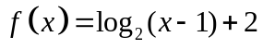  vertical asymptote:_________________  y-intercept:__________ x-intercept:__________  horizontal asymptote:_______________  domain:__________________________  range:___________________________  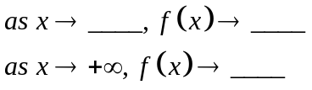  Exponential Parent Function: __________________ | Example 8: Graph: 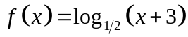  vertical asymptote:_________________  y-intercept:__________ x-intercept:__________  horizontal asymptote:_______________  domain:__________________________  range:___________________________  Exponential Parent Function: __________________
  y = __________ |  |  | y = __________
  x | y |  | x | y
  y = __________ |  |  | y = __________
  x | y |  | x | y
Example 9: Graph: 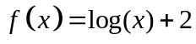  vertical asymptote:_________________  y-intercept:__________ x-intercept:__________  horizontal asymptote:_______________  domain:__________________________  range:___________________________ | Example 10: Graph: 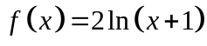  vertical asymptote:_________________  y-intercept:__________ x-intercept:__________  horizontal asymptote:_______________  domain:__________________________  range:___________________________

Exponential Parent Function: __________________
y = __________ |  |  | y = __________
x | y |  | x | y

Exponential Parent Function: __________________
y = __________ |  |  | y = __________
x | y |  | x | y

Day 4 Properties of Logarithms

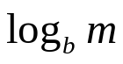 | 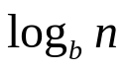 | 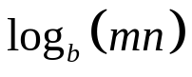
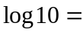 | 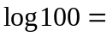 | 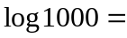
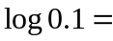 | 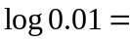 | 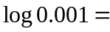
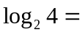 | 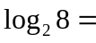 | 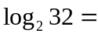

Properties of Logarithms
For any positive numbers m, n, and b where 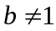:
Product Property:
Quotient Property: 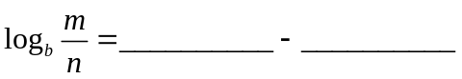
Power Property: 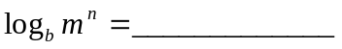

Example 1: Expand the following logarithms.
a) 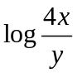 b) 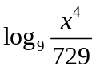

c) 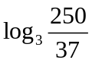 d) 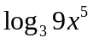

e) Is there a way to expand a) without using the Quotient Property?

Example 2: What is each expression written as a single logarithm?
a) 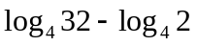 b) 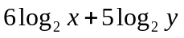

c) 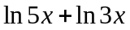 d) 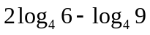

e) f) How can you use the Power Property to simplify
a) ?

LOG
LN
The key on the calculator finds _________. The key finds ________. To evaluate a logarithm with any base, use the Change of Base Formula.

Change of Base Formula
For any positive numbers m, b, and c, with and 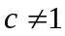: 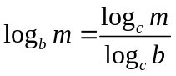

Example 3:
a) Evaluate 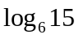 using both common and natural logarithms.

Using TI-84 Plus (with OS 2.55MP)
Use the shortcut key ALPHA -> F2 5: logBASE(

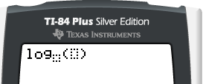
b) Evaluate 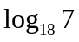.

REVIEW: Graph.
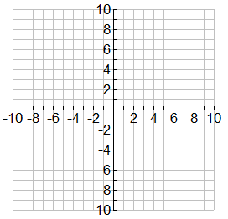
a) 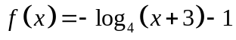 b) 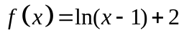

vertical asymptote:_________________ vertical asymptote:_________________
y-intercept:__________ x-intercept:__________ y-intercept:__________ x-intercept:__________
horizontal asymptote:_______________ horizontal asymptote:_______________
domain:__________________________ domain:__________________________
range: ___________________________ range: ___________________________

c) Use 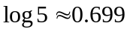 and 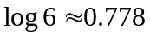 and the properties of logarithms to approximate the value of 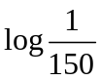.

d) Rewrite 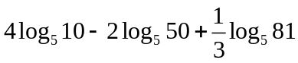 as a single logarithm.
Day 5 Solving Exponential & Logarithmic Equations

You can use _______________________ to solve exponential equations. You can use _______________________ to solve logarithmic equations.

One way to solve exponential equations is to use the postulate that if two powers with the same ___________________ are equal, then their _________________________ must be equal.

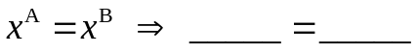

Example 1: Solve.

a) 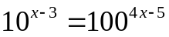 b) 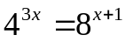 c) 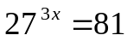

When the bases are not the same, you can solve an exponential equation by taking the ___________________ of both sides (use the definition of logarithm).
Example 2: Solve.
a) 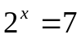 b) 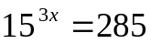 c) 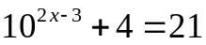

d) 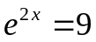 e) 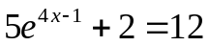

Example 3: Solve.
a) 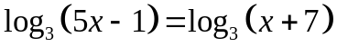 b) 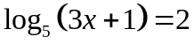

c) 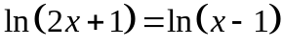 d) 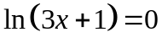

e) 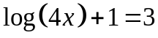 f) 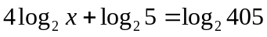

g) 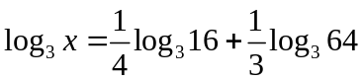 h) 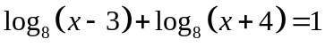

i) 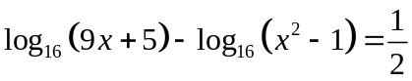

Example 4: You deposit $2000 in an account that pays 2% annual interest compounded continuously. How long does it take the balance to reach $3500?

Finding Inverses
Example 1: Find the inverse of each function algebraically.
a) 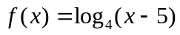 b) 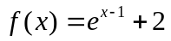 c) 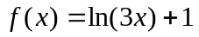

Day 6 - Modeling with Polynomial, Exponential & Logarithmic Functions

Just as two points determine a line, two points also determine an __________________________ curve.

Exponential function:

Example 1: Write an exponential function whose graph passes through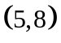 and 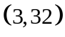.

Example 2: Write an exponential function whose graph passes through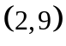 and 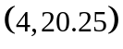.

Example 3: Write an exponential function of the form 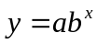 whose graph passes through the given points (use a graphing calculator).
a) 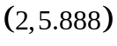, 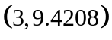 b) 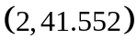, 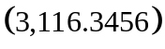

_______________________________________ _______________________________________

c)
x | 1 | 2 | 3 | 4 | 5 | 6 | 7 | 8
y | 14 | 49 | 171.5 | 600.25 | 2100.9 | 7353.1 | 25,736 | 90,075

_______________________________________

d) The table shows monthly premiums for a 10-year term-life insurance policy worth $1,000,000 for males. (These data are provided by Life Quotes, Inc. in USA Today, December 20, 2004.)

age | 40 | 45 | 50 | 55 | 60 | 65
monthly Premium | $29 | $46 | $68 | $106 | $157 | $257

Make a scatterplot of these data on your calculator. Is there a pattern?

- Find a model (exponential or logarithmic) that best fits the data. Justify your answer using the correlation coefficient.

- Using the above model, what is the expected monthly premium of a 37 year old male? Of a 70 year old male?

e) Here is some data on the hearts of various mammals:
mammal | heart weight  (in grams) | length of cavity  of left ventricle (in centimeters)
mouse | 0.13 | 0.55
rat | 0.64 | 1.0
rabbit | 5.8 | 2.2
dog | 102 | 4.0
sheep | 210 | 6.5
ox | 2030 | 12.0
horse | 3900 | 16.0

Make a scatterplot of these data on your calculator. Is there a pattern?

- Find a model (exponential or logarithmic) that best fits the data. Justify your answer using the correlation coefficient.

- Using the above model, what is the expected length of the left ventricle cavity of a blue whale’s heart that weighs 1 ton (1 ton = 2000 lbs; 1 lb = 454 grams)?

f) A motion detector recorded the heights of a ball as it bounced up and down several times. Here are the
heights of the ball at the highest point on the first five bounces.

bounce # | 1 | 2 | 3 | 4 | 5
Height (in feet) | 2.24 | 1.62 | 1.235 | .958 | .756

- Find a model (exponential, logarithmic, linear, or quadratic) that best fits the data. Justify your answer.
- Would the best fit model be suitable for the above situation (useful for future predictions)?

